Lottie Line-Up

Yolanda White – Principal

School Office/Absence Line 586-725-7551  *Lottie M. Schmidt Elementary*

Hello Lottie Families,

This week we have been doing our M-Step Testing for grades 4-5. It has been going well. The students are really doing well and trying their best. Our 4th and 5th graders also visited their middle school for next year and had a great visit. Thank you to everyone for getting back the schedules so quickly. Our second graders had a program on water conservation so you may have some kids timing your showers.

With the Michigan weather acting crazy please make sure your child has their winter coat for recess every day.

Also, if you are going to bring your child in late please remember to call and let us know in the office. That way we can make arrangements for their lunch.

Please be advised our before school clubs start at 8AM. Students can expect the door to be open at that time. Office staff and teachers are here starting at that time. Thank You for your cooperation.

**No School April 18th**

**No students in attendance April 21st**

Please communicate transportation arrangements with your student in the morning. The office only needs to be called if there is a last-minute change from the normal way home. Please make these calls before 3:30pm.

We encourage our families to be signed up to receive text messages from the School District notifying you of cancellations or other issues If you are not already signed up, you can sign up by following the instructions below. Send a text message to (67587) with the words "opt in" or "subscribe" as the message. If you are already receiving text message from Anchor Bay School District no further action is required. For more information you can visit http://schoolmessenger.com/txtmsg/

Yearbook Orders

You can now place your yearbook orders by scanning the link below.

Orders will be taken now through April 27, 2025.

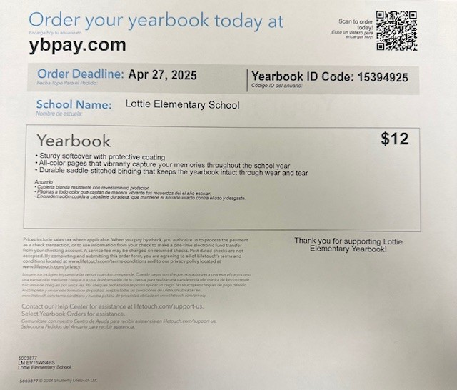





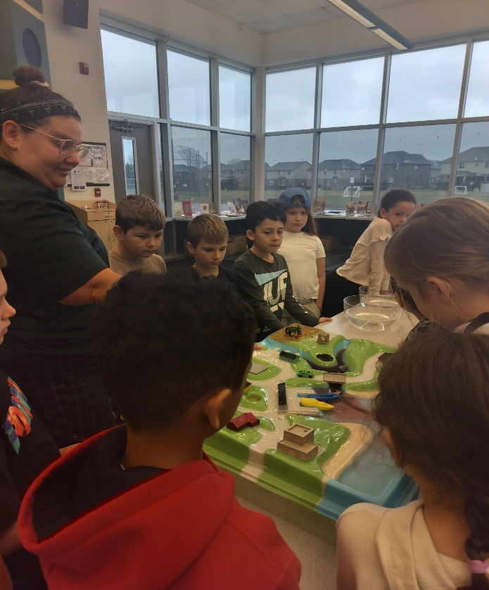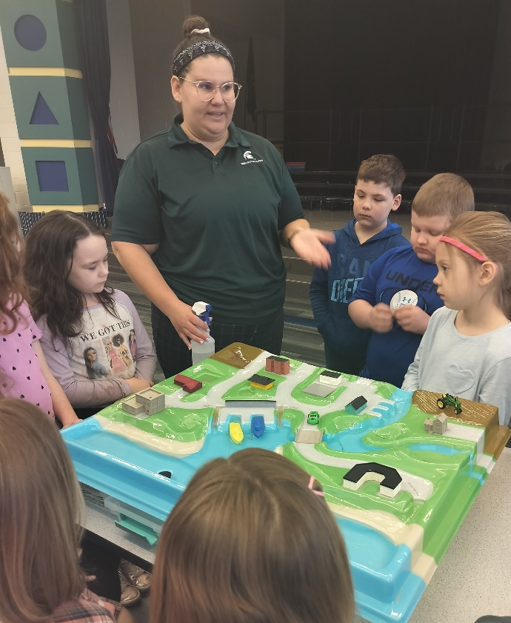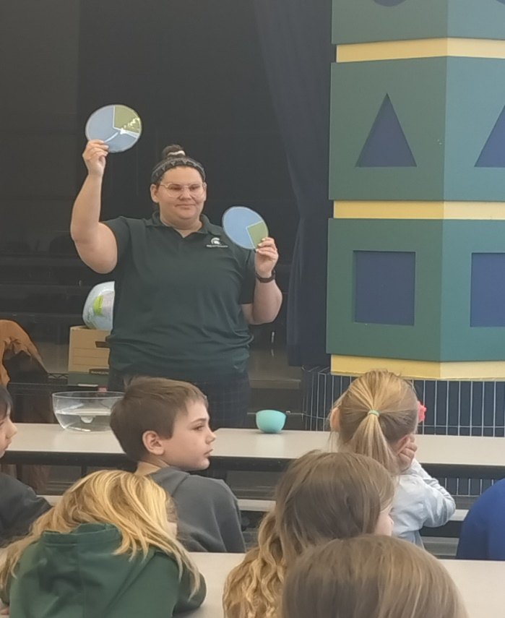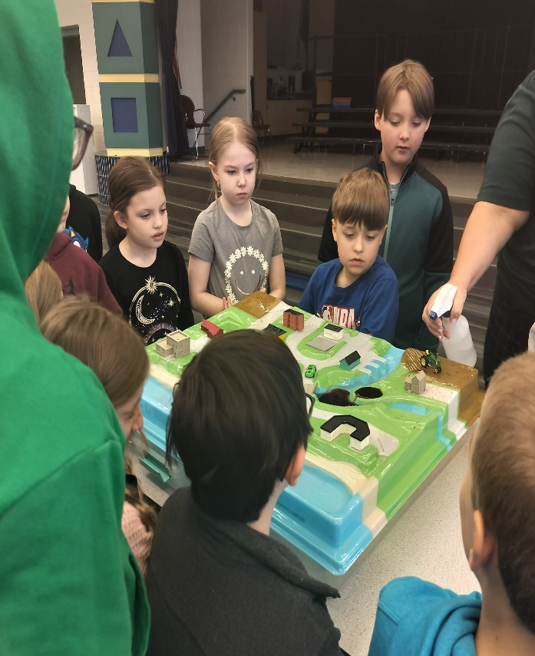Learning about Water Conservation

Last Day of Drawing Club

Mrs. Hurley would like to thank all the students that participated in her drawing club. You all made it a very fun and creative club!

