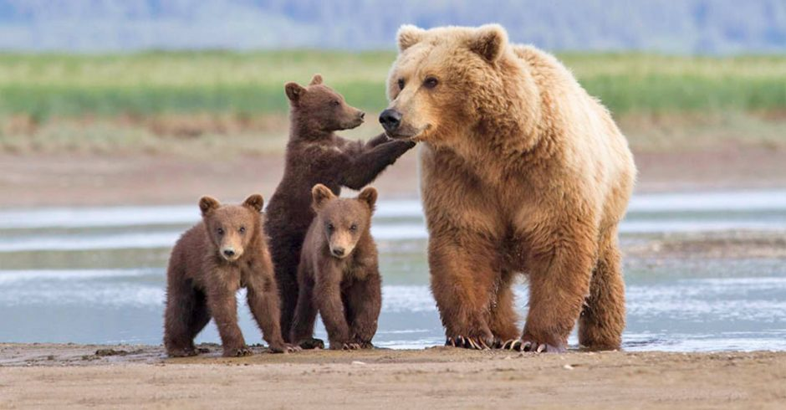

Maconce Bear Stroll 2026!
Dear Maconce Families,
In the past, our school has conducted multiple fundraising events to help offset the costs of the extra materials and programs needed to support achievement and success in our building. This year we have decided to sponsor the Bear Stroll it will maximize the most out of your dollars. There will be nothing for you to buy or sell! Best of all, 100% of the money brought in, goes directly back to your child and not a fundraising company.
Fundraising dollars allows us to purchase supplemental materials to support our Reading and Language Arts Programs, Technology, Life skills and various academic classes. We also use these dollars to offset transportation costs for field trips.
On Thursday, October 22nd, students who help raise money for our school will have the opportunity to leave class, walk the field, go on a hayride, listen to the DJ and have a chance to win some awesome prizes. This is a great way to encourage some physical activity, raise funds for our school, avoid other fundraising companies and have a little fun at the end of the day.
Our goal is for every student to raise a minimum of $15.00 via pledges from family and friends. On the back of this letter is a prize schedule showing what our students will earn depending upon their pledge amounts. In addition to the pledge amounts, raffle tickets give students a chance to win large prizes. Please keep track of pledges and money on the envelope provided.

All money collected is due to your child’s teacher by MONDAY, OCTOBER 19TH to be eligible for prizes and participation.
Cash and checks are accepted. Please makes checks payable to Maconce Elementary.
100% of money raised goes directly to your child’s school!

Thank you for your support!
Sincerely,
The Maconce Staff

